ish¿u ysñlï weúßKs $ All Rights Reserved

St. Peter's College

St. Peter's College

St. Peter's College

புனித பேதுரு கல்லூரி

புனித பேதுரு கல்லூரி

புனித பேதுரு கல்லூரி

புனித பேதுரு கல்லூரி

புனித பேதுரு கல்லூரி

புனித பேதுரு கல்லூரி

புனித பேதுரு கல்லூரி

புனித பேதுரு கல்லூரி

Ydka; mS;r úÿy,

Ydka; mS;r úÿy,

Ydka; mS;r úÿy,

Ydka; mS;r úÿy,

Ydka; mS;r úÿy,

Ydka; mS;r úÿy,

Ydka; mS;r úÿy,

Ydka; mS;r úÿy,

Ydka; mS;r úÿy,

Ydka; mS;r úÿy,

St. Peter's College

St. Peter's College

St. Peter's College

St. Peter's College

St. Peter's College

St. Peter's College

St. Peter's College

St. Peter's College

St. Peter's College

St. Peter's College

புனித பேதுரு கல்லூரி

புனித பேதுரு கல்லூரி

புனித பேதுரு கல்லூரி

புனித பேதுரு கல்லூரி

புனித பேதுரு கல்லூரி

புனித பேதுரு கல்லூரி

புனித பேதுரு கல்லூரி

புனித பேதுரு கல்லூரி

Ydka; mS;r úÿy,

Ydka; mS;r úÿy,

Ydka; mS;r úÿy,

Ydka; mS;r úÿy,

Ydka; mS;r úÿy,

Ydka; mS;r úÿy,

Ydka; mS;r úÿy,

Ydka; mS;r úÿy,

Ydka; mS;r úÿy,

Ydka; mS;r úÿy,

St. Peter's College

St. Peter's College

St. Peter's College

St. Peter's College

St. Peter's College

St. Peter's College

St. Peter's College

41

**I,II**

**wmrÈ. ix.S;h**

**Western Music**

**meh 02**

**Two Hours**

**09 fY%aKsh – m<uq jdr we.hsu - 2024**

***Grade 09 – First Term Examination - 2024***

Ydka; mS;r úÿy, - fld<U 04

புனித பேதுரு கல்லூரி, கொழும்பு 4

***St. Peter's College - Colombo 04***



Name: ''''''''''''''''''''''''''''''''''''''''''''''''''''''''''''''''''''''''''''''''''''''' Class: '''''''''''''''''''' No: ''''''''''''''''''

**Part - I**

* **Underline the most suitable answer.**

01. The time signature for the following is,

|  |
| --- |
|  |
|  |
|  |
|  |

i. C ii. iii. iv.

02. Number of semiquavers in a dotted minim is,

i. 8 ii. 12 iii. 6 iv. 4

03. The enharmonic equivalent of A double flat is,

i. A flat ii. B iii. F double sharp iv. G flat

04. A perfect 5th has _______ semitones,

i. 7 ii. 9 iii. 5 iv. 4

05. The letter name of the following note is,

|  |
| --- |
|  |
|  |
|  |
|  |

i. A ii. C iii. A sharp iv. C sharp

06. Who is considered as the prince of concerto?

i. Bach ii. Mozart iii. Beethoven iv. Haydn

07. Which of the following is known as AB form?

i. Ternary ii. Rondo iii. Sonata iv. Binary

08. Which of the following is a major triad?

|  |  |  |  |
| --- | --- | --- | --- |
|  |  |  |  |
|  |  |  |  |
|  |  |  |  |
|  |  |  |  |

09. The composer of the 48 preludes and fugues is,

i. Bach ii. Handel iii. Mozart iv. Beethoven

10. In which period does programme music became popular?

i. Modern period ii. Romantic period

iii. Classical period iv. Baroque period

11. The nationality of the composer of the Peter and the wolf is,

i. Russian ii. German iii. Austrian iv. French

12. In oriental notation Sa and Pa are known as _________ swara,

i. Chala ii. Achala iii. Mandra iv. Uchcha

13. Ma in oriental notation is the same as,

i. Fah ii. Ray iii. Me iv. Soh

14. The light song “Olu Pipila” was sung by,

i. Ananda Samarakoon ii. W. D. Amaradewa

iii. Mohideen Beg iv. Sunil Shantha

15. To which type of folk song does the given extract belong?

Inne dumbarai maha kalu galak yata

Kanne karawalai rata hale bathata

Bonne bora diyai pooruwe kala pawata

Yanne kavadada mavpiyo dakinnata

i. Goyam kavi ii. Pal kavi iii. Pathal kavi iv. Gel kavi

16. How many tones are there in an octave?

i. 12 ii. 11 iii. 6 iv. 5

17. Which of the following is the key signature of A flat major?

|  |  |  |  |
| --- | --- | --- | --- |
|  |  |  |  |
|  |  |  |  |
|  |  |  |  |
|  |  |  |  |

18. The time signature for simple quadruple time with minim beats is,

i. ${2 \atop 2}$ ii. iii. iv.

19. Which of the following instrument plays the bass part of a string quartet?

i. Violin ii. Viola iii. Cello iv. Double bass

20. Which pair of terms gives the similar meaning?

i. Diminuendo , Decrescendo ii. Piano , Forte

iii. Pianissimo , Fortissimo iv. Allegro , Adagio

**(20 Marks)**

**Part - II**

* **Compulsory question.**

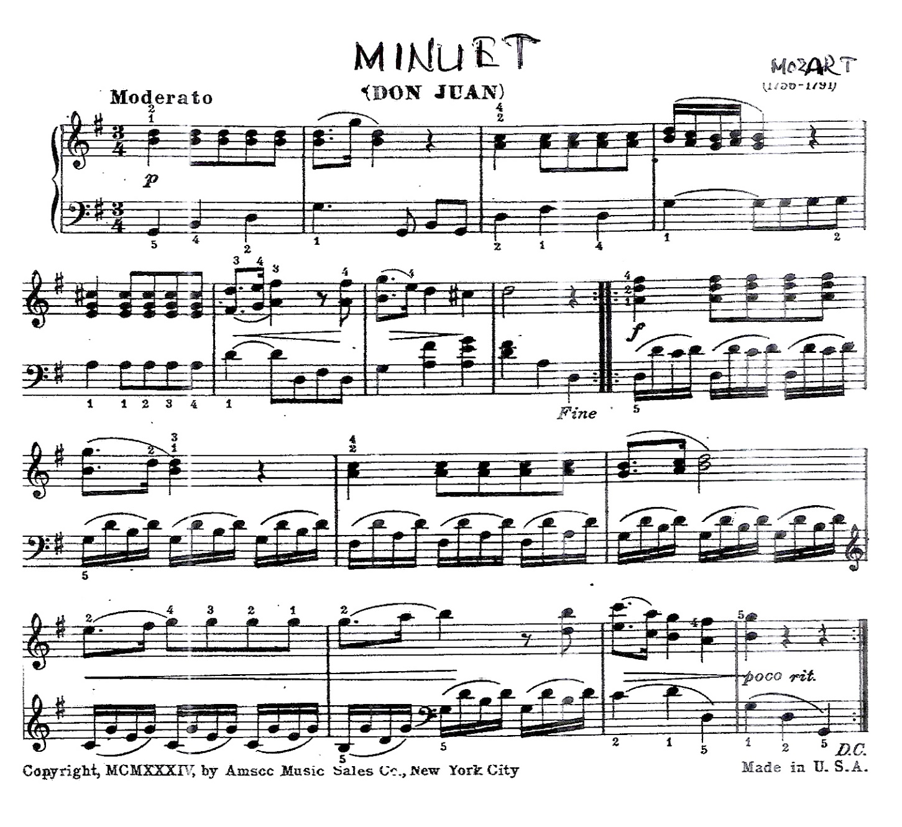01. Questions are based on the following music.

1. Write the full name of the composer.

2. To which period does he belong?

3. Name a contemporary composer.

4. What is a minuet?

5. Explain the time signature,

6. In which key is this written?

7. The letter name of the circled note is ___________

8. Name the interval marked at A.

Write the English meaning of the following.

9. rit -

10.

**(10 Marks)**

* **Answer only two questions.**

02. 1. Convert the following oriental notation to western notation.

|  |
| --- |
|  |
|  |
|  |
|  |

m ${}^{/}$. ${}^{/}$ m | O - ks | O ß - | m - - - **(04)**

i

u

u

u

2. Convert the following melody in to oriental notation.

|  |  |  |  |
| --- | --- | --- | --- |
|  |  |  |  |
|  |  |  |  |
|  |  |  |  |
|  |  |  |  |

__________________________________________________________ **(04)**

3. Write the letter name of the following notes. **(02)**

|  |  |  |  |
| --- | --- | --- | --- |
|  |  |  |  |
|  |  |  |  |
|  |  |  |  |
|  |  |  |  |

**(10 Marks)**

03. 1. Peter and the wolf is a musical tale for children. Name the musical instruments which represent these characters in this story.

The bird - The duck -

The cat - Grandfather -

Peter - **(05)**

2. Name the composers of these works.

Four seasons -

1812 -

Peter and wolf -

Carnival of animals - **(02)**

3. Write the following notes.

|  |  |  |
| --- | --- | --- |
|  |  |  |
|  |  |  |
|  |  |  |
|  |  |  |

F double sharp

below the staff

B sharp

above the staff

B flat

below the staff

**(03)**

**(10 Marks)**

04. 1. Write one octave ascending of the major scale with the given key signature. Write as crotchets, mark semitones. **(03)**

|  |
| --- |
|  |
|  |
|  |
|  |

2. Insert a clef, accidentals of 3 flats and complete this scale. Write the name of the scale.

**(03)**

|  |
| --- |
|  |
|  |
|  |
|  |

Name. _______________________________________________________

3. Write the correct interval. **(02)**

|  |  |
| --- | --- |
|  |  |
|  |  |
|  |  |
|  |  |

Perfect 5th

Major 3rd

4. Write the correct triad with key signature. **(02)**

|  |  |
| --- | --- |
|  |  |
|  |  |
|  |  |
|  |  |

Tonic triad of F major

1st inversion

Dominant triad of G major

root position

**(10 Marks)**